No | Activity Name | Classification | Rationale
1 | Writing a new chapter for a novel/nove | Just me | I prefer to use my own language in stringing together each paragraph. The results produced by AI also do not touch the reader's emotions.
2 | Outline the story/research topic of each new chapter of the book | Collaborate with AI | In compiling story ideas, sometimes writers take a long time to develop story ideas. AI helps and reduces writers' time in determining the direction and storyline
3 | Defining a new strategy/direction for an etsy shop | Just me | Decisions of business vision and market instincts entirely require human intuition and taste.
4 | Looking for the latest trends for a niche etsy shop | fully automate | Using AI to the fullest greatly minimizes time
5 | Merancang SEO listing product etsy ( Titile, keyword, description) | Collaborate with AI | AI is very good at finding good keywords or descriptors so that potential buyers can find products more easily, I just need to check the authenticity of each word
6 | Replying to etsy store customers' messages/comments | Just Me | In replying to messages, sometimes AI doesn't understand the buyer's intent and purpose. I choose to do it myself to maintain the comfort of the buyer
7 | Conducting research on the latest technological developments | Full automate | Doing research takes a lot of time, AI can do it in a few seconds
8 | Create the latest skill learning ouline | Full automate | It is very difficult to determine the direction of learning, let alone new skills, AI gives the right path if it is given the right program
9 | Fix project errors | Collaborate with AI | Ai provides a solution, I just need to make sure the results are accurate and suitable for the application in my program code
10 | Looking for startup-scale business ideas that have great potential in a specific region | Full Automate | Ai is great at doing research in a short time, by giving the right promt, Ai can give relevant ideas and have a high level of marketing
11 | Develop business ideas by mapping each job into small jobs and assisting in their creation | Collaborate with AI | Usually I choose a business idea in the world of technology, AI is needed in determining the direction, and the first step to start it. And build selected systems/ideas. I just need to evaluate it

Claude Project with custom instructions
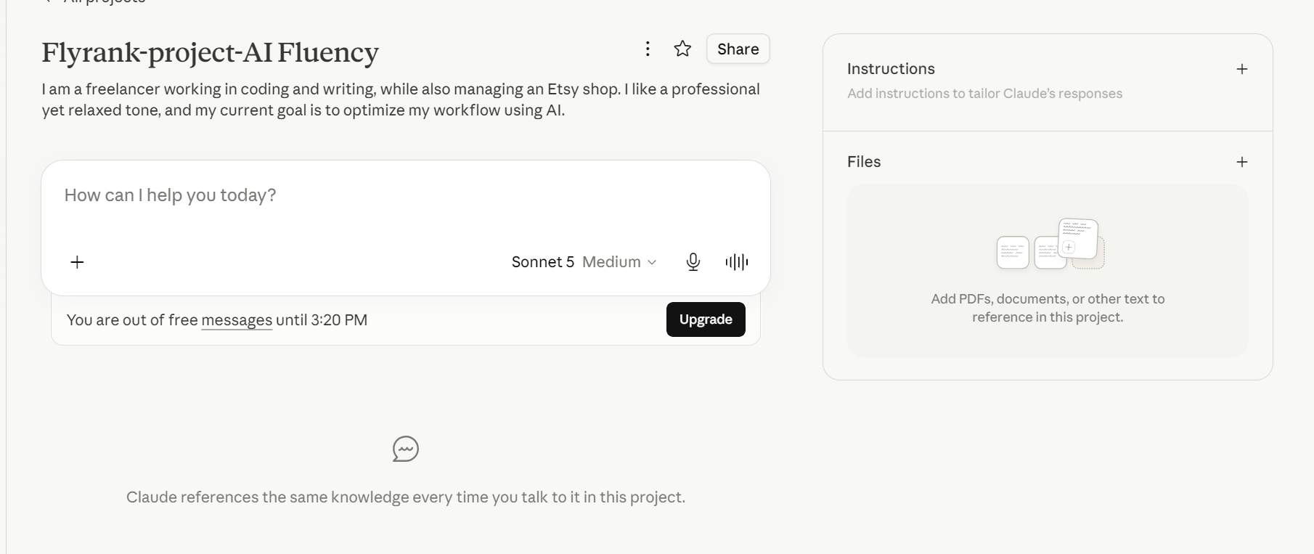

Anthropic Academy
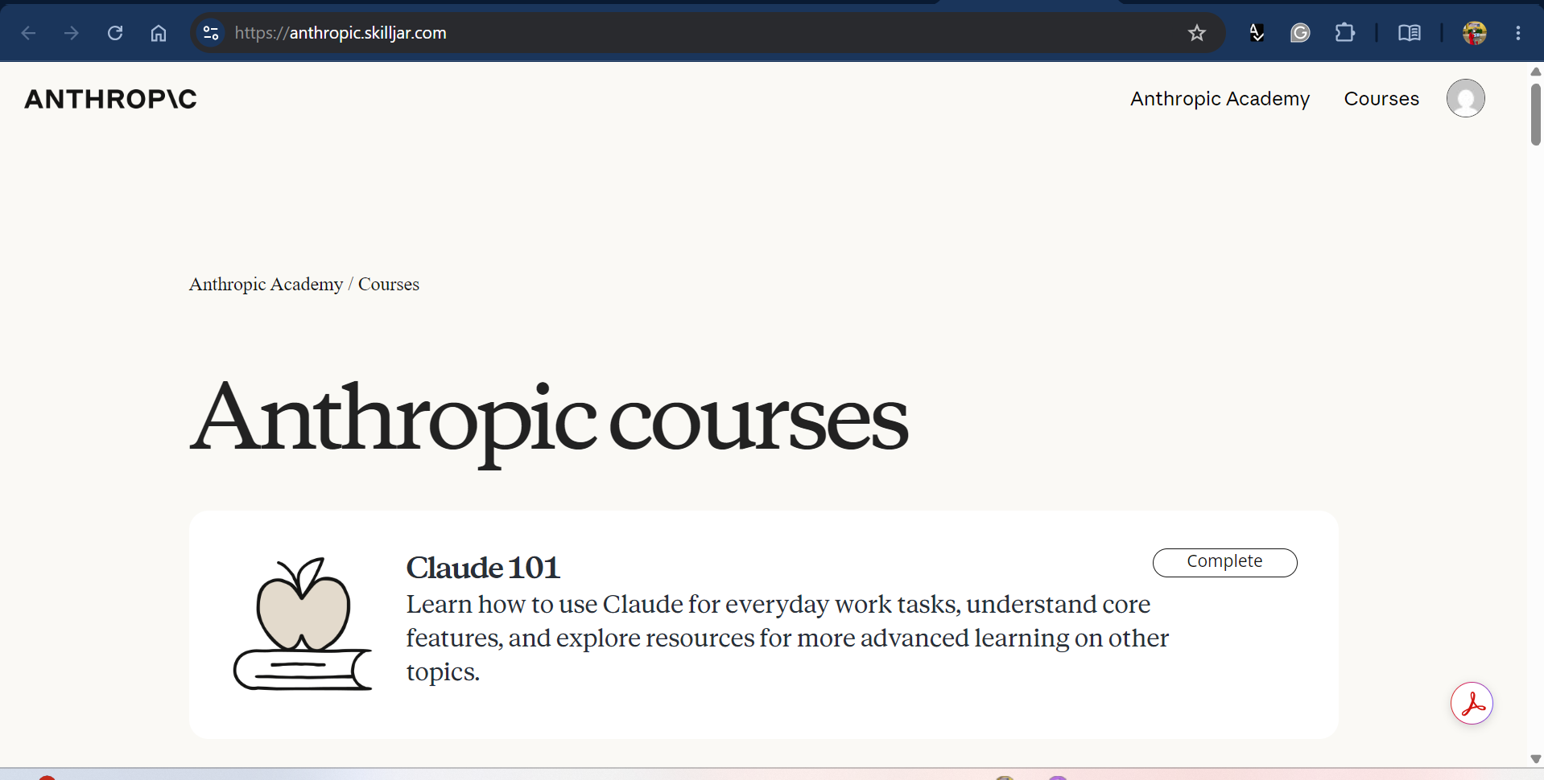

Three target tasks with success definitions
Designing SEO product listing on etsy (Titile, keyword, description) and determining trends
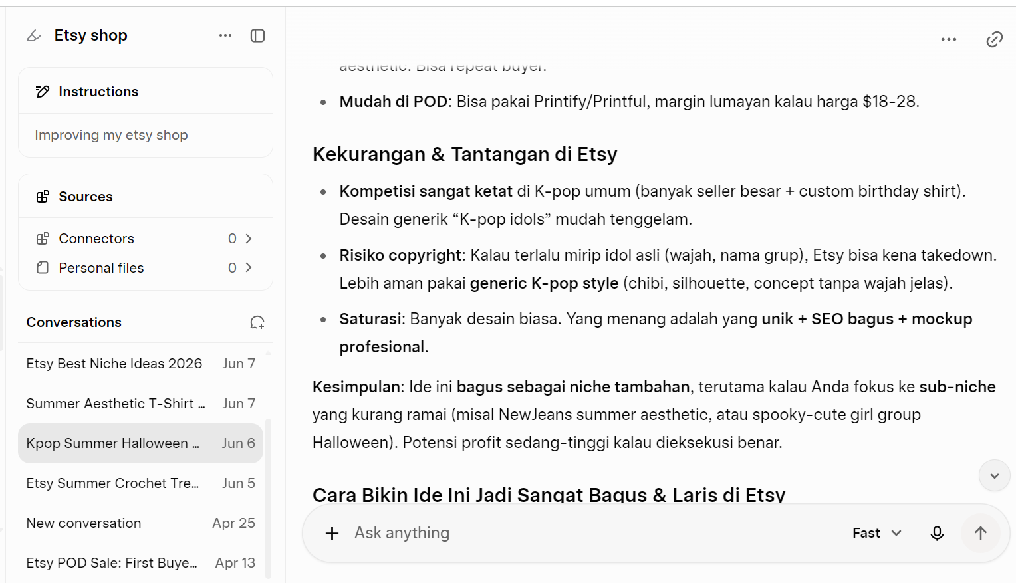
Collaborate with AI to develop business ideas
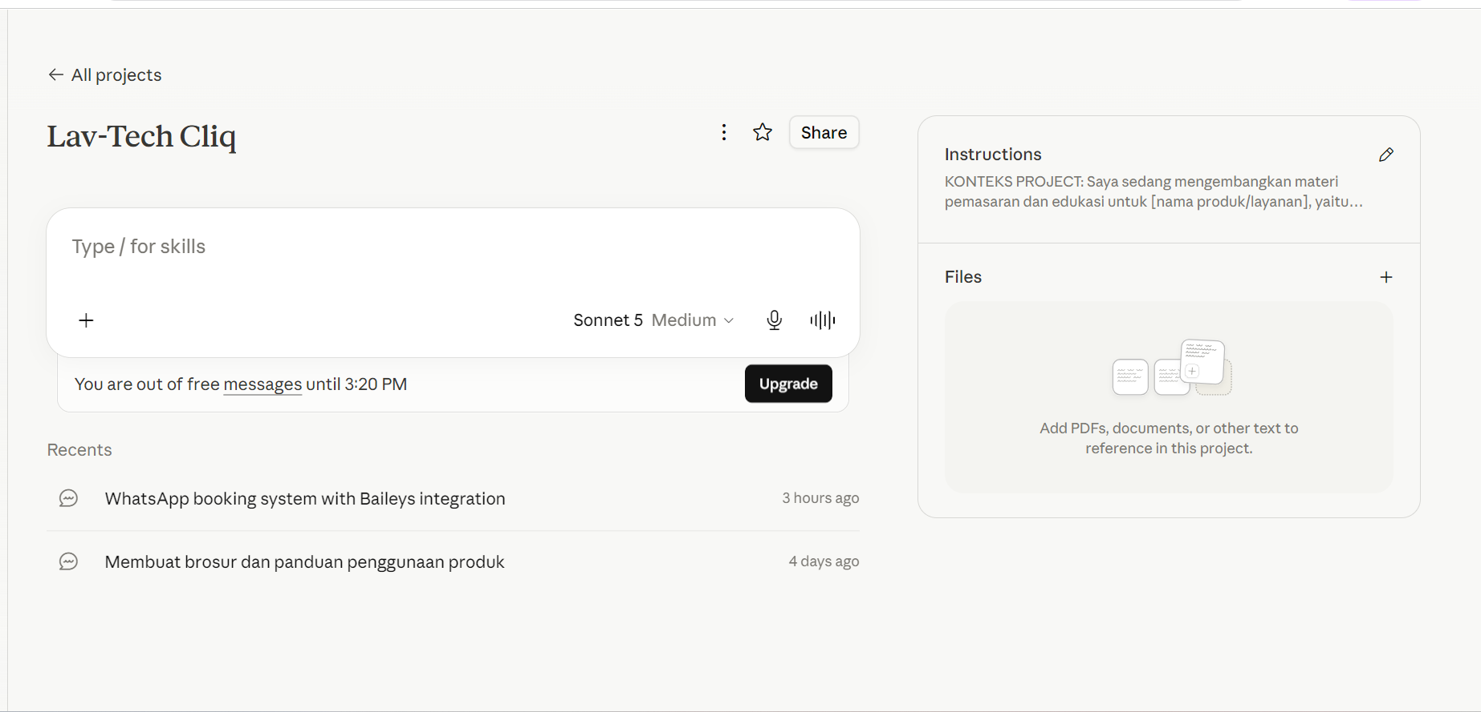
Outline the story/research topic of each new chapter of the book
